More on ‘That Sound!’
By Roberto Pistolesi with foot notes by Jim Nugent

A while back, my friend Ronnie Gustafsson and I began to develop a theory which opened a new horizon in our research. We had realised that when we tried to reproduce the guitar sound on tunes like Shadoogie, Gonzales, Theme From Shane, Shotgun or Back Home with a Gretsch Country Gentleman, we were having difficulty in achieving the right response on the lower strings - even though we felt that this was the right guitar for the sound on the original recordings.

During these experiments, we found that whenever the sound of the B and E strings was convincing and almost identical to the original, the tone of the bass strings was not so convincing and lacked something of the fresh live and ringing tone of those original records. We first concluded that this was probably due to the fact that we were not using the right type of strings, or perhaps because Hank’s amplifier had a different sound due to a different placement of the microphone in front of it, or a special equalisation used on the recordings - never forgetting that they were done in the famous Studio 2 at Abbey Road!

But another interesting point to consider is that Malcolm Addey has stated that when recording the Shadows, his brief was clearly to reproduce the actual sound which the Shadows were making in the studio (insofar as the prevailing technology allowed). This was achieved via the accurate placement of microphones and without using any particular special effect - and this means that the sound that we hear in the records was (as nearly as can be reproduced) the sound delivered by Hank’s amplifier.

Overall, and as we were not satisfied with our results, we were convinced that there was something to research.

Further study of the available documents focused our attention on the following points:

1. In Mike Read’s ‘The Story Of The Shadows’, Hank is quoted as remembering:

“As soon as you got down to the lower strings on a guitar the comparison with Duane Eddy was inevitable, so we just had to try and achieve a different tone or style or use different echo. We’d actually been to see him earlier in the year at the Edmonton Regal and renewed our acquaintance with his road manager Charlie Carpenter whom we’d worked with in the States. One of the main factors in Duane’s success was the fantastic amplification system at that time. He had a large fifteen-inch speaker which gave what seemed like really full depth and power with an eight-inch speaker on top for the treble! It was all packed solidly with foam rubber and encased in a steel chassis, so result was full volume without distortion. It seemed so incredible at the time that it inspired us to experiment with amplification and new sounds as long as we could reproduce them on stage”.

As the Shadows were using (stock?) Vox amplifiers on stage at the time, does this mean that they had begun to work on a ‘custom’ amplifier model in co-operation with Jennings Musical Industries (VOX), or that they were testing different models and brands of amplifiers?

2. Remembering the 1961 South Africa tour (reported in the same volume), Bruce says:

“We did our first ever live recording during that trip, at the Coliseum where we recorded Shazam, Sleepwalk, FBI and Guitar Boogie. We were promised Vox amps for the tour but we ended up being given Gibson amps which of course had to be used for the live recording as well. This was the only time that Vox amplifiers weren't used on our recordings”.

Interestingly, Bruce forgot to mention the Selmer-Truvoice amplifiers that they used at least on the ‘Cliff’ LP which featured the Shadows’ Jet Black, Driftin’ and Be-Bop-A-Lula. Was there any need to specify that Vox amplifiers were used on all their recordings? ...unless he wanted to keep the use of other brands a secret - or to give publicity to VOX?

3. In the book ‘The Vox Story’ by David Petersen and Dick Denney, the author writes:

“…The definitive solution to the problem lay in an additional piece of circuitry that could be added to AC30s as an extra, or built-in at the factory. In the catalogue, it was called the Top Boost unit but was known to its makers as the Brilliance unit. This was developed by Dick Denney in response to the Shadows’ request for a Fender-like range of tone controls on one channel of their amplifiers. The modification was introduced during 1961, but proved problematic for non technical Vox owners to fit. Consequently, most units are factory fitted…”.

Surprisingly enough, this circuit was not developed by Dick Denney. An in-depth analysis of diagrams covered in guitar amplifier handbooks has revealed that the same circuit with identical components values was used by the Gibson company in their GA-70 and GA-77 amplifiers back in 1956! The most curious thing is that Fender never used a circuit identical to this in their amplifiers an interesting and curious way to achieve a “Fender-like” range of tone controls in a Vox amplifier...

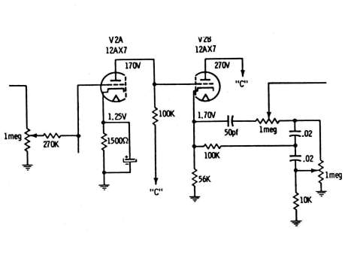
Detail of the Gibson GA-77 schematic.

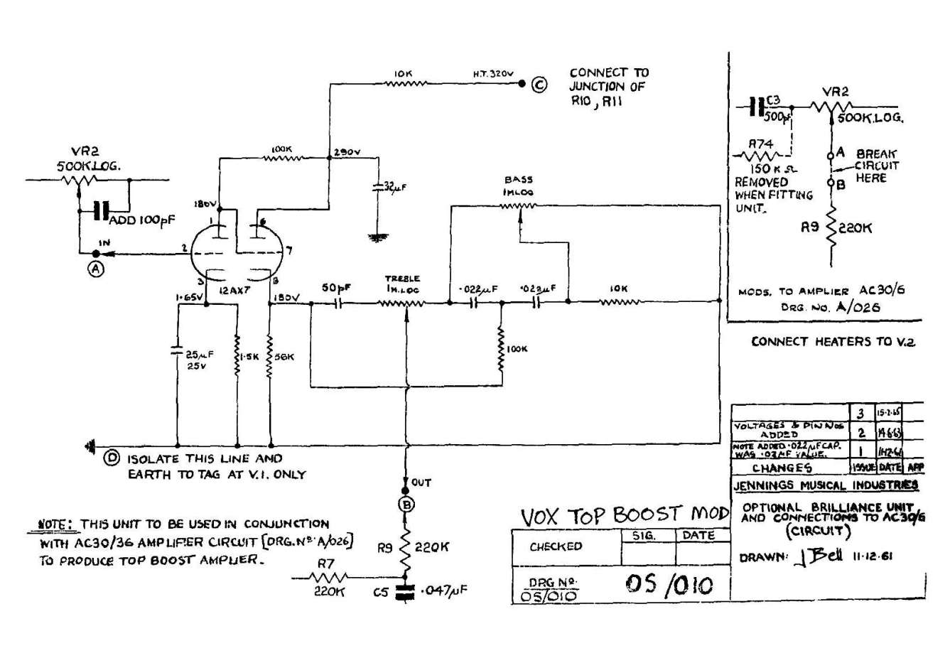
The Vox Brilliance unit (Top Boost) schematic.

As there is no information, photograph or declaration which confirms the use of a special custom built or different amplifier than Selmer or Vox on the early recordings, we decided to do some further research, as after all, our dissatisfaction with the sound - and the above mentioned points - are good reasons to doubt that only Selmer and Vox stock amplifiers were used on the recordings. This research is like a jigsaw puzzle, every piece must fit exactly in its place and, most importantly, every piece must have a gap to fit!

There are still several questions that need to be answered in order to give to this story a logical time-line. Analysis of these questions and an attempt to answer them in a logical way forms the basis of our next attempt to fill the gap.

There is no doubt that in order to make an extensive research of the roots of That Sound, we have to listen hard to the work that The Shadows did on Cliff’s recordings. After having researched the EMI Archives for as many recording information as possible, I created a database of all the Shadows’ studio recordings from the beginning of their career until the end of 1968. The list included both the recordings of the Shadows and the recordings of Cliff & The Shadows, making a total of more than five hundred titles with their respective recording date and details. A click with the mouse and all the titles were put in chronological order according to the given recording date.

With the help of invaluable friends like Jim Nugent (UK) and Giorgio Sguigna (IT), I was able to listen to the listed songs in the order they were recorded. I then had the facility to listen to them and to attempt to analyse how it was that That Sound developed and evolved over those golden years of the late 1950s and early 1960s.

Whilst listening to this Chronology, I noticed several curious things that were worth deeper investigation...

For instance, there are several photos of Cliff Richard with two Neumann U47 microphones placed in front of him, and that is because early stereo pop recordings (still in an experimental stage at EMI) employed dual microphone set-ups, with the stereo engineer sitting in the ‘stereo room’ next to Studio 2 and picking up the output of the microphones that he had placed as doubles of those which had been positioned for the routine mono recording.

For unknown reasons, a few songs were recorded in mono and stereo at different dates and the released versions were taken from different master tapes. This happened several times, but there are three of Cliff’s songs that are particularly interesting. We Have It Made was recorded twice - on 26 July 1959 and on 24 June 1960. What’d I Say and I Want You To Know were also recorded twice - on 13 October 1960 and on 4 March 1961.

When listening to these songs, the listener realises immediately that Hank’s guitar has a very different sound from one version to the other, although other sounds on the records, including Cliff’s voice, are almost identical. The two guitar sounds are so far away from each other that there could be only one reasonable explanation: Hank recorded the two sessions with two different guitars! This is undoubtedly possible (even for the confirmed Gretsch-sceptic), because in 1960 Hank was still using Cliff’s maple neck Stratocaster, whilst from March 1961 onward he had the use of a new rosewood neck Stratocaster (and he also had, from September 1959 onward, the Gretsch Country Gentleman as a spare guitar). We thought that if we would be able to replicate accurately these two sounds, then we would have made another step forward in our research.

After several attempts, we realised that in the recordings of 26 July 1959 and 13 October 1960, Hank had used the Fender Stratocaster and on those of 24 June 1960 and 4 March 1961, he had used the Gretsch Country Gentleman. But though we got a convincing sound with both guitars, there was still ‘something missing’, especially in the versions that we ascribed as having been recorded with the Stratocaster, as we were not able to reproduce accurately that particular ‘sharp’ sound. So we decided to investigate amplifiers.

That decision to experiment with amplifiers was also supported by the fact that whilst the Selmer-Truvoice Stadium could easily replicate the effect heard on the July 1959 version of We Have It Made, neither the Selmer with its Goodmans speaker, nor the AC 15 tested alternatively with a Goodmans and a Celestion G12, were able to deliver the kind of tremolo found on the recording of 24 June 1960. Importantly, we ought to remember that That Sound is (partially) present on "Move It", because of the distinctive sound of the lead guitar. Despite the fact that none of the (later) Shadows were present, just think how many people later assumed that Hank was playing on that record!

In fact, when listening to the intro of Move It, it is easy to associate the sound with that of several following Shadows’ recordings, although it is well known that the lead guitarist on Move it was Ernie Shear, as Ian Samwell - who wrote the song - recalled:

“In addition to Cliff, Terry Smart and myself there were two other people in the studio who would turn out to be more helpful to us than we could possibly have imagined, guitarist Ernie Shear and bassist Frank Clarke. They were both quite a few years older than we were, and, to look at them, you really wouldn't automatically have associated them with rock 'n' roll… Ernie Shear was short and stocky with dark wavy hair and horn rimmed glasses. Originally from Scotland, Ernie as a young man had moved to London and, at the tender age of fifteen, joined the Oscar Rabin Band. For Move It he played a beautiful blond Hofner guitar with a DeArmond pick-up near the bridge.

“It has been suggested that he used a Fender amp although I doubt that - it seems too early. The British government were still busy rebuilding the post-war economy, and import restrictions were still firmly in place. Ernie would have had to travel to the United States or import it himself. It's more likely that he would have used a Selmer or some such… Norrie decided that, because Ernie's guitar, amp and playing were much better than mine, he should be the one to play the introduction - a great executive decision. Despite the fact that the intro is, to say the least, somewhat unusual (it begins with a quaver rest), Ernie 'got it' immediately. We agreed that he should also play the first two bars of rhythm, and that I would take it from there, leaving him free to play the fills.”

According to Jim Nugent who did an interview with Ernie Shear some years ago, the amplifier used on Move It was a Fender Deluxe and therefore we decided that experimenting with the sound of old Fender amplifiers could be interesting, and at least it would expand our knowledge.

In 1959, the Fender FINE ELECTRIC INSTRUMENT catalogue listed ten models of amplifiers ranging from the top-of-the-line Twin Amp to the small student-sized Champ Amp. But we focused our attention on two amps only: the Vibrolux Amp and the Tremolux Amp (which were the only models to have the built-in tremolo effect which Hank used on some recordings). Both models were studio sized and operated with the same type of output valves (tubes): the 6V6GT. The main differences between them were the use of a “heavy duty” 10” Jensen speaker for the Vibrolux and an “extremely heavy duty” 12” Jensen speaker for the Tremolux, with the latter having a more advanced circuitry, which used three preamp valves instead of the two, used on the Vibrolux. However, the rectifier valves were not identical, and if a 5Y3 was powerful enough for the power requirements of the smaller Vibrolux, the Tremolux took advantage of the more generous capabilities of the 5U4.

As many of my customers are vintage collectors, it was not difficult for me borrow an example of each amp from two of them and importantly, both amps had been freshly serviced in my shop!

A few days later, some friends were invited to spend an afternoon in my rehearsal room and help me with playing the guitars and attempt a first evaluation test. The guitars were linked alternatively to the amplifiers through a custom built hi-quality A/B footswitch, and the original recordings were played through a pair of Tannoy monitor speakers put side by side to the amps.

A detailed chronicle of that afternoon, although very exciting, would be too long to be chronicled, just try to imagine a bunch of enthusiastic and very nostalgic people listening for the first time to That Sound coming out directly from an amplifier! Of course, we gave the priority to those tunes that we had ascribed to be played originally with the Stratocaster and, to our surprise, we immediately achieved the sound that was so difficult to get before! Needless to say, the Gretsch Country Gentleman also performed to advantage when being played through the Fender amplifiers. We could hear that for the first time during our experiments, the sound was identical to the original in the lower strings when playing tunes like Shadoogie, Gonzales, Theme From Shane, Shotgun, Back Home, Peace Pipe, Find Me A Golden Street or My Resistance Is Low - and also the sustain of the guitar was increased by these Fender amps. The last question to be answered is: which of these two amps sounds closer if not identical to the sound of the Shadows’ recordings?

Incidentally, I ought to mention that about a year ago (2002), in the continuous search for That Sound, I started to experiment with a small Gibson amplifier, the Explorer model manufactured in 1959 or 1960. That amp gave me (and other people who heard it at Tilburg) the feel of the original recordings. After an in-depth study of its circuit, I recently realised that the Gibson Explorer and Fender Vibrolux schematics are identical with the exception of one capacitor value. Both amplifiers used the same valve array (2 12AX7s, 2 6V6GTs, 1 5Y3), the same type of speaker (Jensen P10R) - and the cabinets were of the same wood and size! I tested the Explorer against the Vibrolux and I have to conclude that the Fender sounds better, with a more focused and sturdy sound than its Gibson counterpart. These are subtle differences, nevertheless they are noticeable by a well trained ear during an A/B test (technically speaking, I ascribe the difference to the better quality capacitors and output transformer used by Fender). And three generations of players can’t all be wrong - good as Gibson amps have always been, Fender amplifiers have consistently outsold them - worldwide - many times over!

Coming back to our last question, I - supported by all those friends who attended the tests - would choose the Fender Tremolux Amp as the one that sounds the closest to the sound achieved by Hank on many early studio recordings. Like the Vibrolux that was placed one step up from the Gibson Explorer, the Tremolux is one step over the Vibrolux, probably due to its better speaker (Jensen P12Q) and to a more ‘advanced’ (for the time) driver circuit of the output valves. This amp has also the ‘bite’ or ‘punch’ heard in the original recordings with the same ‘breathing’ tremolo effect.
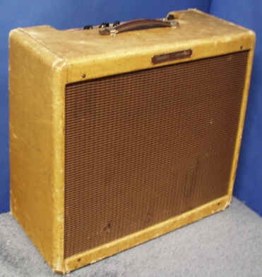

A well preserved example of the Fender Tremolux.

Although I think we have filled some empty patches in the jigsaw - and relocated some pieces that I think had been put in the wrong place - it is still far from complete. There are still things which need to be investigated and questions to be answered in order to enlighten other obscure corners of the story of That Sound – the sound of the Shadows.

Roberto Pistolesi – May 2003

JN: However, local ex-employees of Jennings Musical Industries in Kent say that the amplifiers supplied to the Shadows were to some extent different from the normal ones sold to the public – with selected best-quality components and fully screened with aluminium sheet and foil lining inside the cabinets
This fact was confirmed by an informative article written by EMI studio engineer Malcolm Addey for the (now defunct) “Shadows Circle of Friends (Australia)” news magazine a few years ago.
In a 1995 telephone interview (conducted by Jim Nugent for the UK magazine “Guitarist”), Ernie confirmed the use of the Hofner President guitar [incorrectly amended by the magazine to read “Committee” in order to match an archive photo they had acquired], the DeArmond FHC pickup and importantly – to the very best of Ernie’s memory - a Fender Deluxe amplifier.
JN: Although he didn’t specify the time-frame, Hank has stated that he has “experimented” in the studio with “...little Fender Reverb amps...” (see interview in “International Musician” magazine, UK, February 1976).

